Weekly Assessment for Delta Operations on ESA and CESA-listed Salmonids and Osmerids including Current Delta Hydrologic Conditions
  - Final: Tuesday, January 20, 2026 at 3 PM
Table of contents

Executive Summary

ESA and CESA-listed Salmonids
- Entrainment management season is active.
- Season Loss: 0 (0.00% of threshold) DNA Winter-run, 0 (0.00% of threshold) Hatchery Winter-run, 43.91 (0.83% of threshold) Natural Steelhead, 148.05 (2.5% of threshold) Hatchery Steelhead, and 992.49 (45.14% of threshold) Spring-run Surrogates.
- Winter-run presence in the Delta is decreasing (winding down).
- Steelhead presence in the Delta is high (historical peak).

ESA and CESA-listed Osmerids
- Entrainment management is currently active.
- Delta smelt are primarily distributed west of the confluence, in Suisun Marsh
- No Delta smelt or longfin smelt salvage has been observed this water year
- Turbidity in the central/south Delta is moderate.

1 Current Delta Hydrologic Conditions

1.1 Operational and Regulatory Conditions
Entrainment management is the current controlling factor. See most recent weekly outlook for more information.

1.2 Current Conditions
Most recent inflow at Freeport in the Sacramento River and Vernalis in the San Joaquin River is 40,775 and 2,488 cfs respectively. Most recent 1-day, 5-day, and 14-day OMRI measurements were -4,020, -4,019, and -5,061 respectively, and most recent export data were 3,551 for Jones Pumping Plant and 1,734 for Henry O. Banks Pumping Plant.
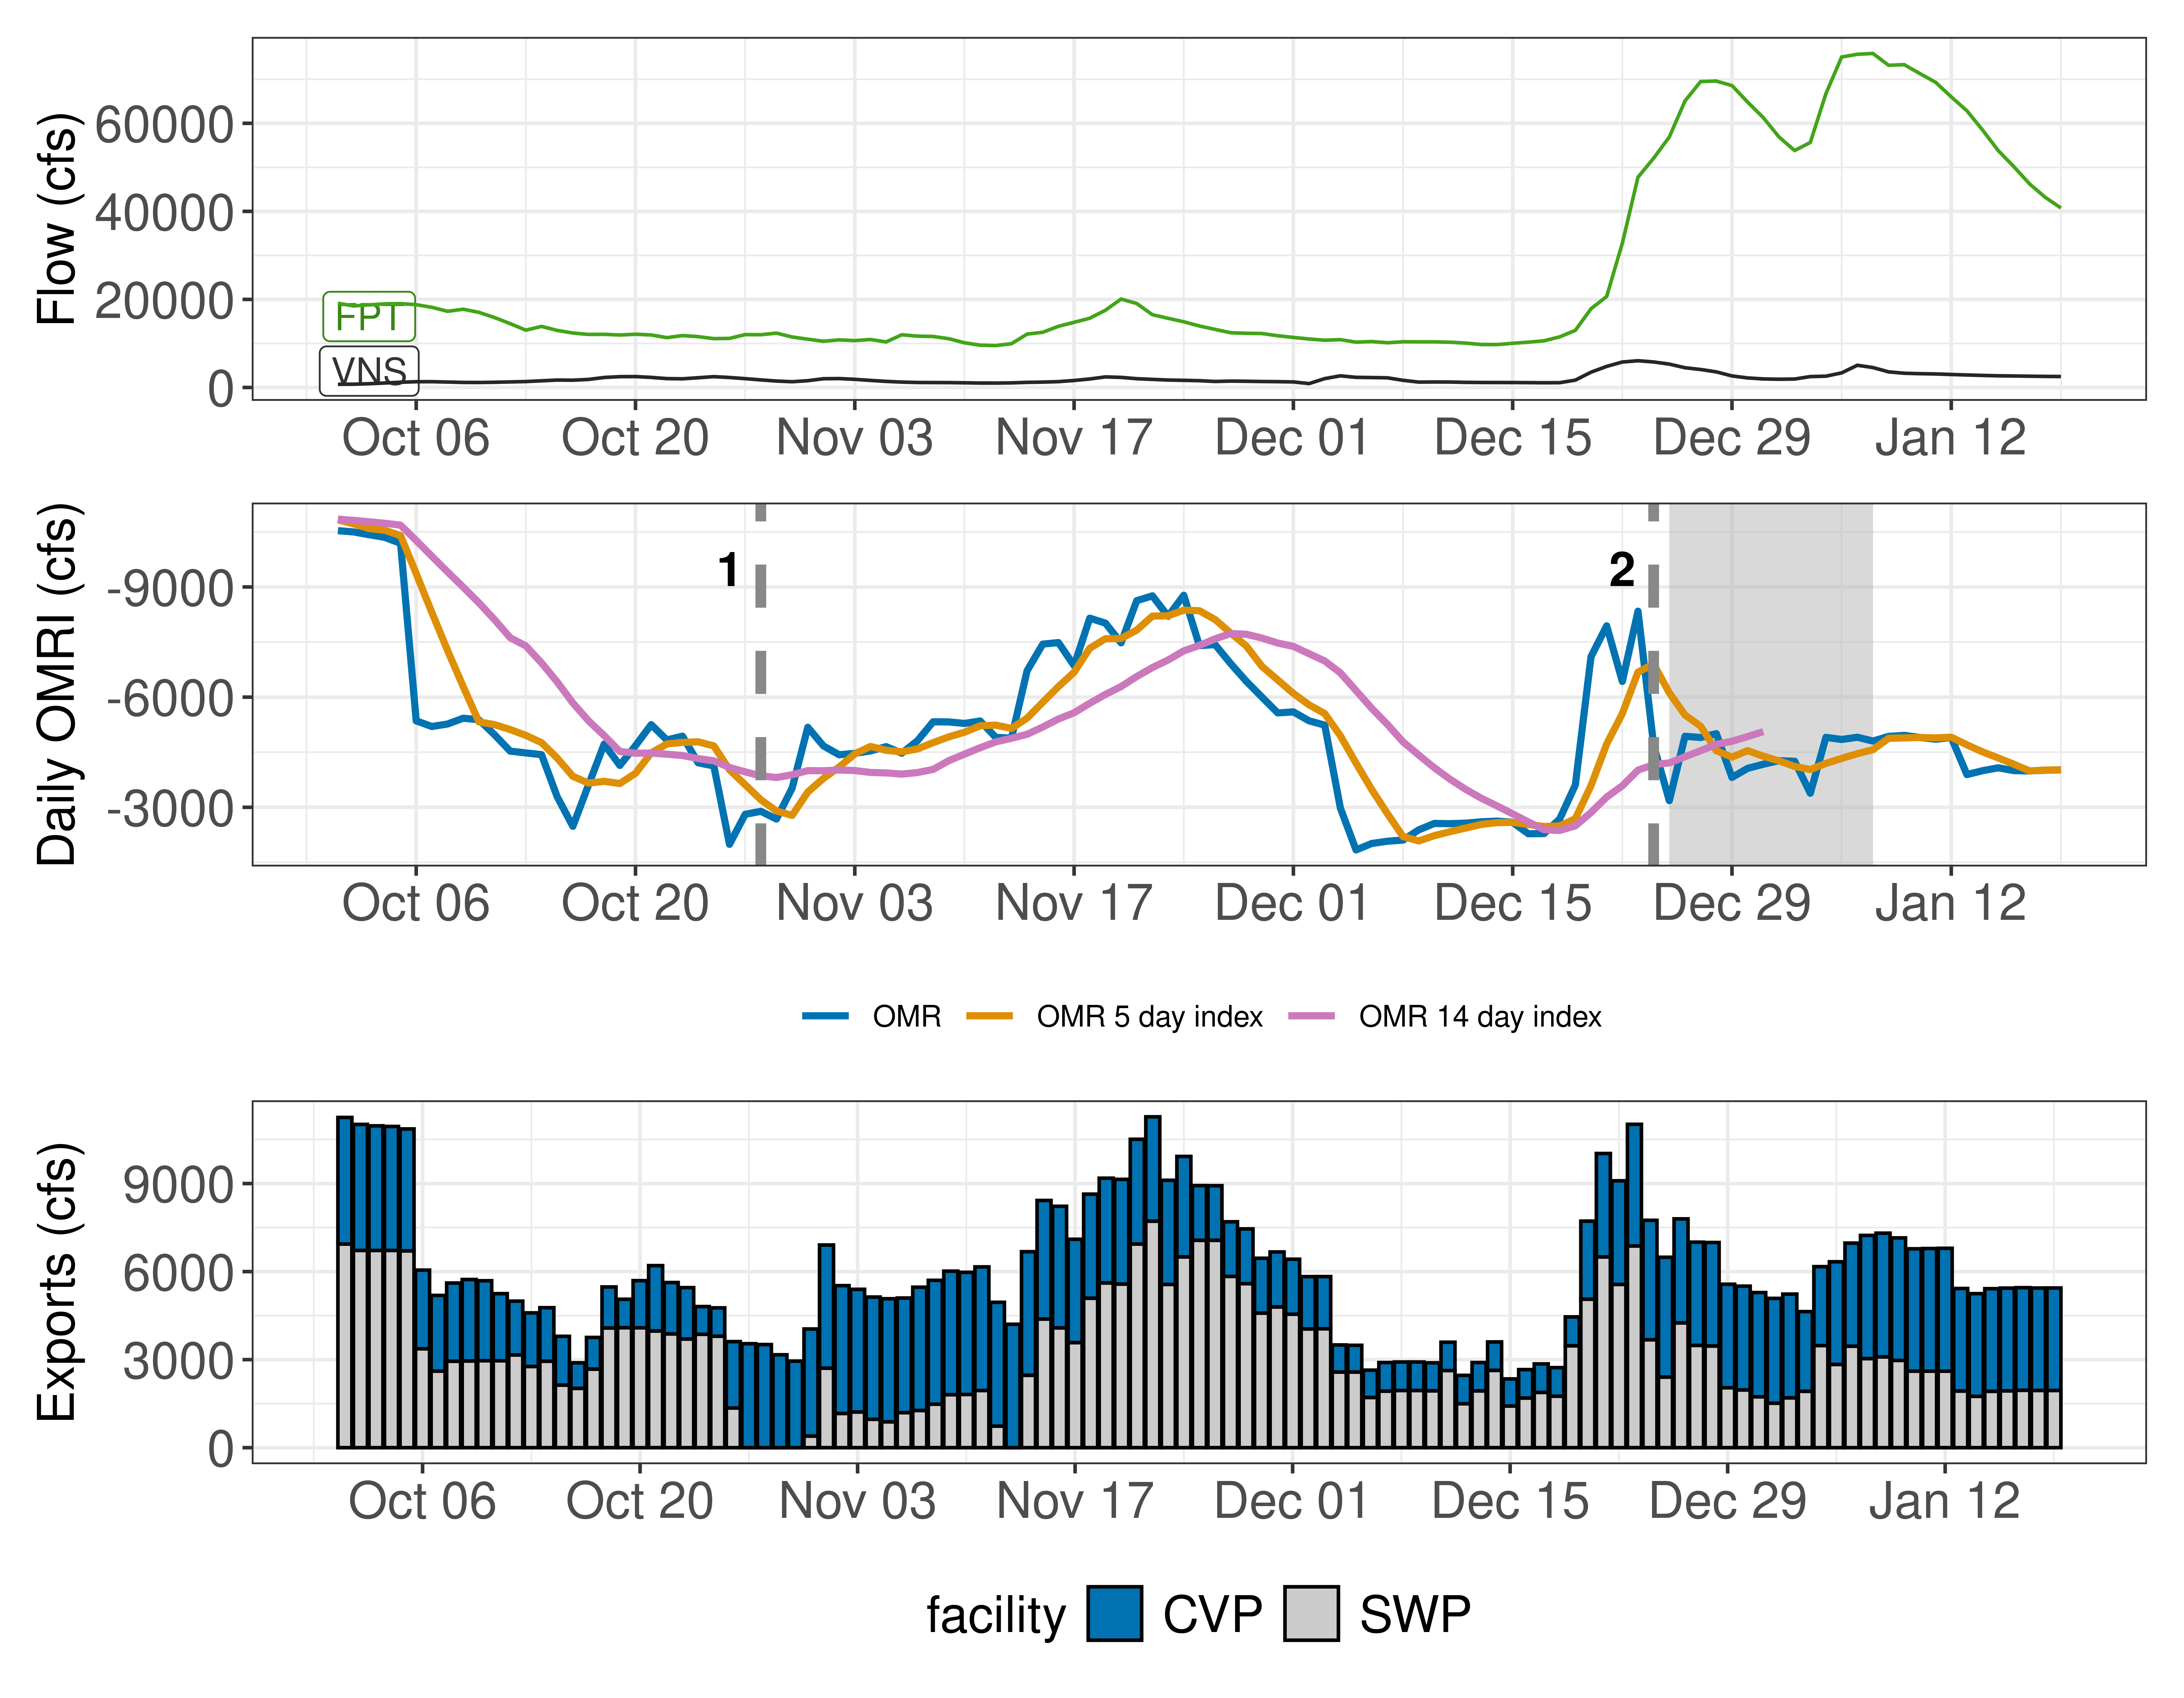
Figure 1: Operations and Action Summary, WY 2026. The numbers and dashed lines in the OMRI plot indicate different triggers (see Table 1), with shading representing specific action periods. OMRI data (colored lines) calculated by SacPAS, Freeport (FPT) and Vernalis (VNS) flow data from CDEC, and CVP (TRP) and SWP (HRO) exports data from CDEC.
Table 1: Summary of Actions and Triggers, WY 2026
Label | Action | Date Triggered | Date Implemented | Number Days Implemented | Regulation
1 | DCC Gate Closure | 10/28/2025 | 2025-10-30 | Ongoing | DCC gates
2 | First Flush | 12/24/2025 | 2025-12-25 | 14 days | Entrainment Management

1.3 Zone of Influence
Zone of Influence (ZOI) analysis is discussed in detail in the December 22 assessment. Current conditions were queried from most recent Freeport flow data on the Sacramento River and Vernalis flow data on the San Joaquin river from SacPAS. Forecasted flows were queried from short range deterministic flows provided by the California Nevada River Forecast Center.
Current conditions at Freeport and Vernalis indicate that delta hydrology falls within the ‘himed’ category. Forecasted conditions averaged across the next 7 days falls within the ‘himed’ category.
The altered channel length for the current “himed” hydrology is 23, 53, 118 and 111 kilometers (km) across OMR bins of -2000, -3500, -5000 and <-5500 respectively. The altered channel length for forecasted “himed” hydrology is 23, 53, 118 and 111 kilometeres (km) across OMR bins of -2000, -3500, -5000 and <-5500 respectively.
Change in altered channel length between OMR levels is 88 km for current conditions and 88 km for forecasted conditions indicating that ZOI impacts across OMR scenarios would not change between current and forecasted conditions. Across the nine hydrology bins, changes in altered channel length across OMR scenarios are moderate (between 25th and 75th percentiles) for both current and forecasted hydrology.
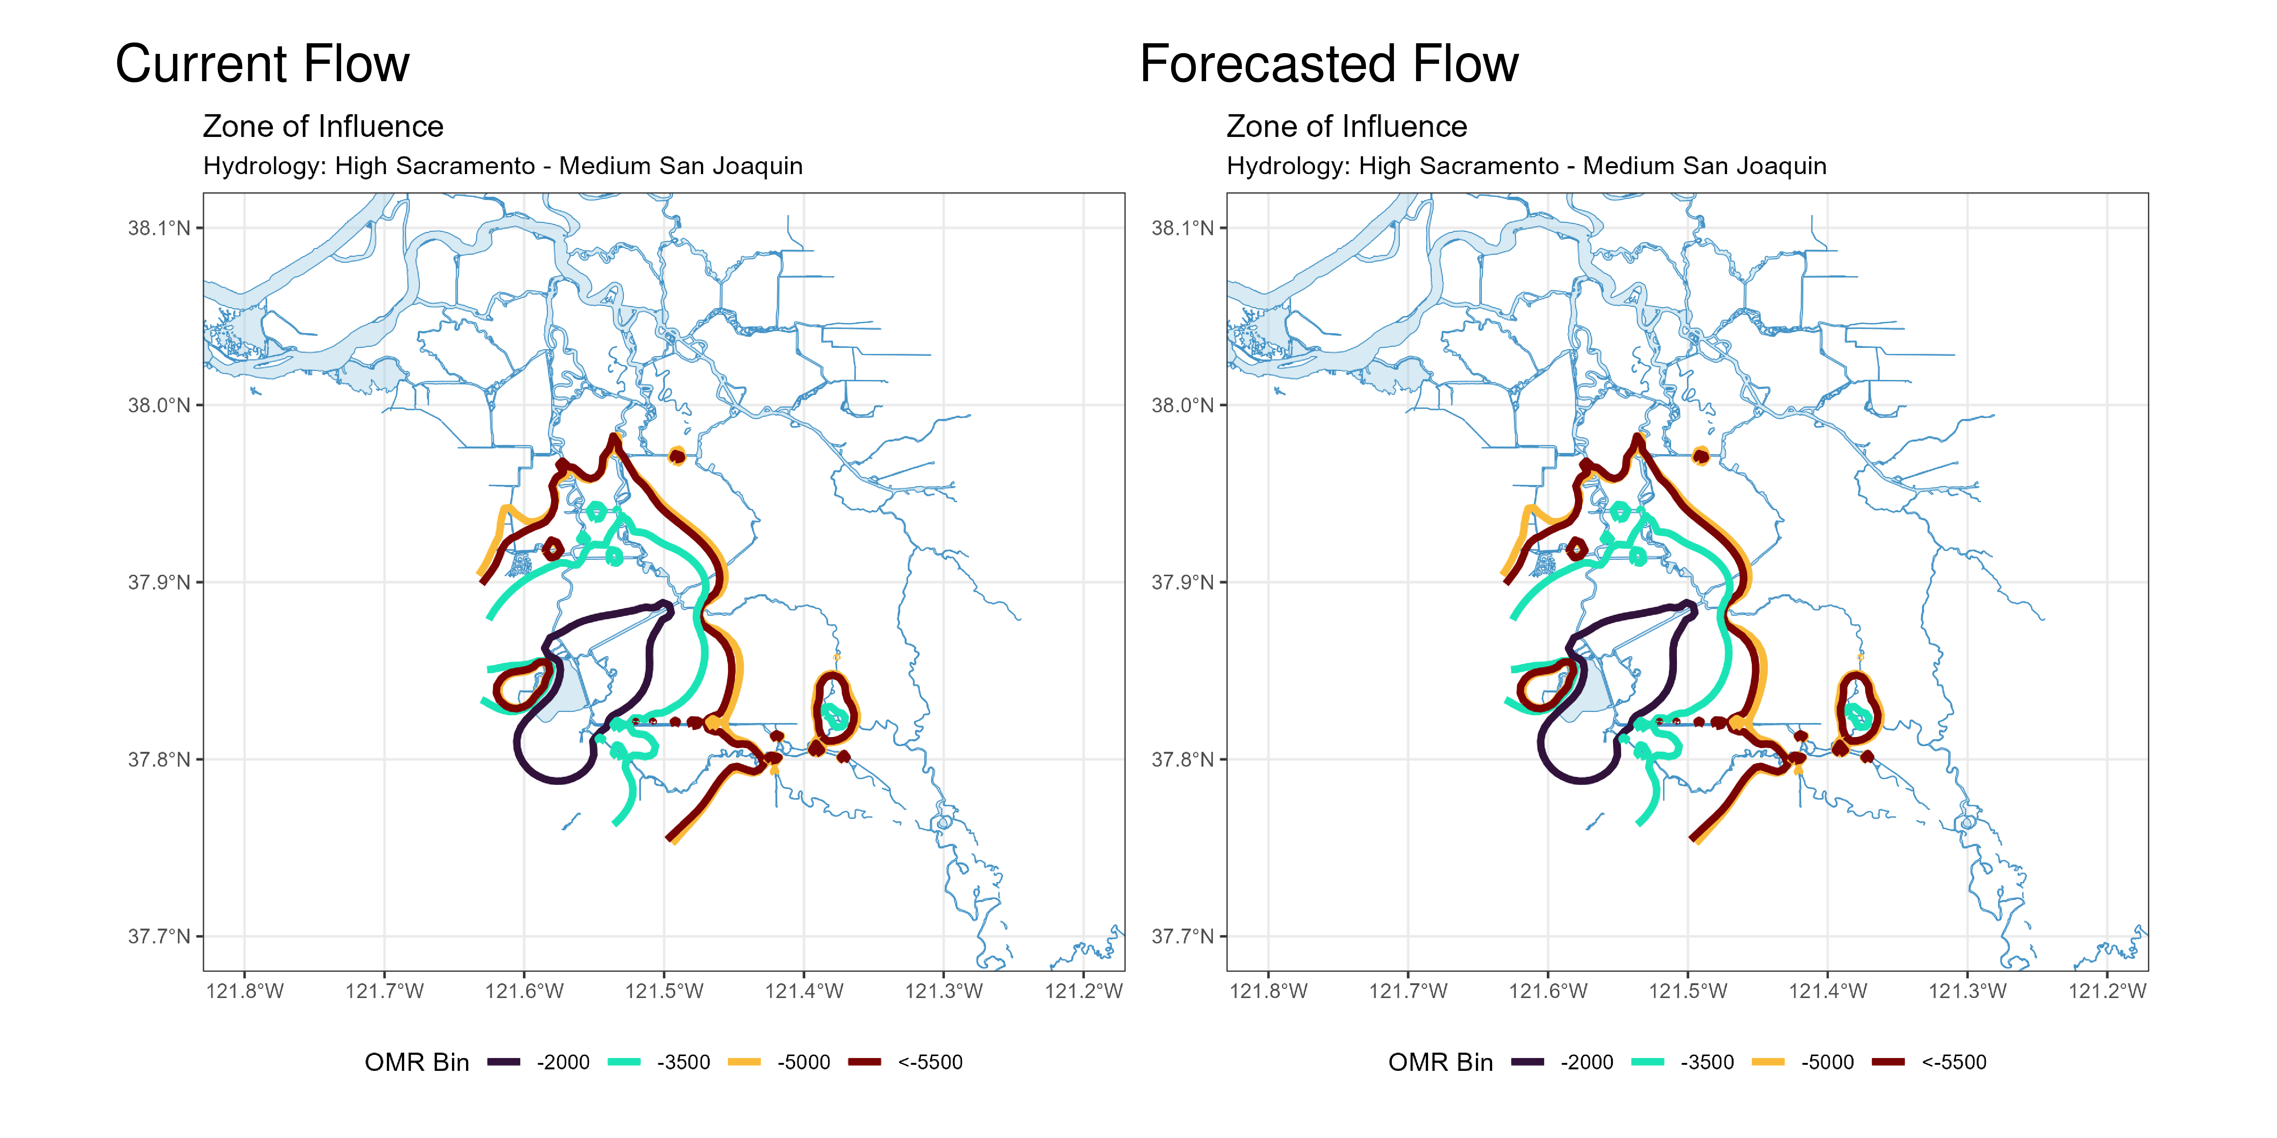
Figure 2: Modeled Zone of Influence at different OMRI scenarios based on current inflow hydrology (left) and forecasted inflow hydrology (right) from the Sacramento River and San Joaquin River

2 Assessment for Delta Operations on Salmonids
For more detailed data on salmonid conditions in the Delta see corresponding webpage on SacPAS.

2.1 Natural Winter-run Chinook

2.1.1 Juvenile Production Estimate
The Juvenile Production Estimate for winter-run is 1,057,452 for the current water year.

2.1.2 Current Status
Entry Timing - Historically, as of Jan 19, 78% of length-at-date (LAD) winter-run have entered the delta based on Knights Landing RST catch, 2% have exited the delta based on Chipps Island Trawl Catch, and 2% of DNA confirmed winter-run have been salvaged.
Table 2
Species | Red Bluff Diversion Dam | Tisdale RST | Knights Landing RST | Sac Trawl (Sherwood) | Chipps Island Trawl | Salvage
Chinook, LAD Winter-run, Unclipped | 98% | 84% | 78% | 42% | 2% | 19%
Chinook, DNA Winter-run, Unclipped (Water Year) | NA | NA | NA | NA | NA | 2%

Red Bluff Diversion Dam Passage Estimate - As of Dec 31 estimated passage to date of LAD winter run at Red Bluff Diversion is approximately 4.16 million fish. * Note that outmigration timing overlaps with spring run migrating fish, and true winter-run abundance likely differs from these estimates.
Delta Monitoring - Total catch of LAD winter run at RSTs at Delta Entry (Tisdale, Knights Landing, Lower Sacramento River) between Jan 06 and Jan 12 is 129 individuals. Total catch at Sacramento Trawl and Beach Seines in the delta between Jan 07 and Jan 16 is 3 individuals. Total catch at Delta Exit at Chipps Island between Jan 06 and Jan 08 is 0 individuals.

2.1.3 Annual Loss
The annual Loss threshold for natural winter-run is 1% of the jpe or 10,574.52 fish. As of January 19, cumulative loss of genetically confirmed winter-run is 0 or 0.00% of the annual loss threshold. Cumulative loss in the past 7 days has been 0.
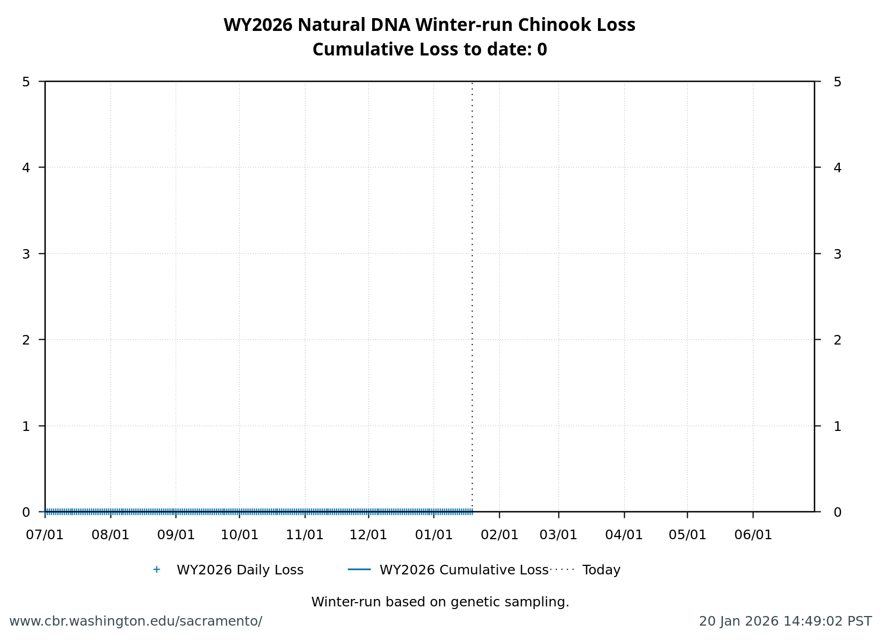
Figure 3: Cumulative loss of natural-origin winter-run for WY 2026. Cumulative loss is based on genetically confirmed winter-run captured in salvage or length-at-date winter-run in which genetic confirmation was unable to be obtained

2.1.4 STARS
The Delta STARS Model is an individual-based simulation model that predicts survival, travel time, and routing of juvenile salmon migrating through the Sacramento–San Joaquin River Delta. This model gives insight into survival and routing patterns of winter-run based on most current conditions.
As of January 19, overall through delta STARS estimated survival probability (with 80% credible intervals) is 0.65 (0.59-0.71) placing it in the 80th percentile of historical STARS survival estimates for the month of January (WYs 2018-2025). STARS estimated routing and survival probabilities (with 80% credible intervals) into the interior delta are 0.12 (0.1-0.13) and 0.38 (0.23-0.53), respectively, corresponding to the 23rd and 77th percentiles of historical January estimates (WYs 2018-2025).
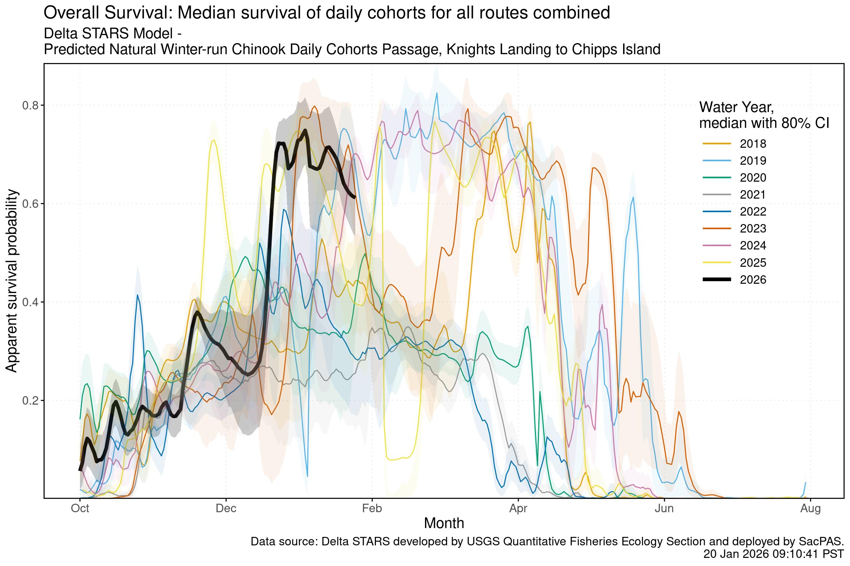
Figure 4: Estimated overall winter-run survival from Knights Landing to Chipps Island. Black line indicates the current water-year, and other colored lines correspond to past water years.
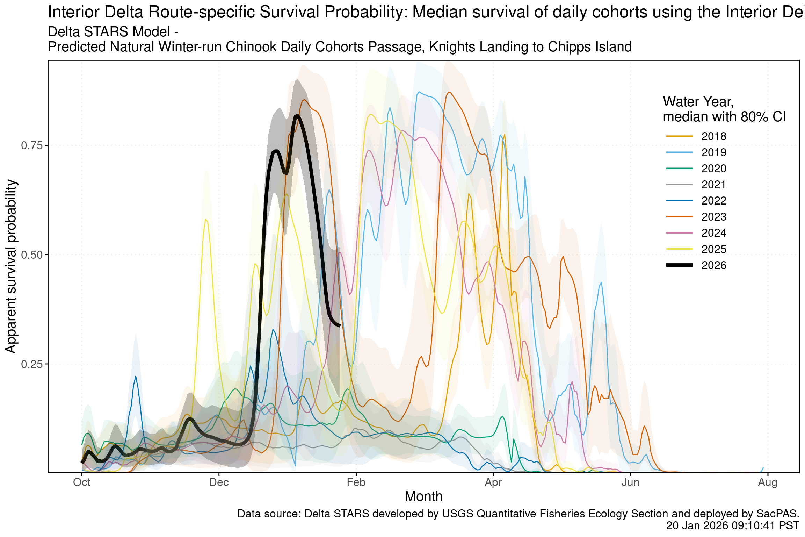
Figure 5: Estimated survival from Knights Landing to Chipps Island of simulate winter-run cohorts that route through the interior delta. Black line indicates the current water-year, and other colored lines correspond to past water years.
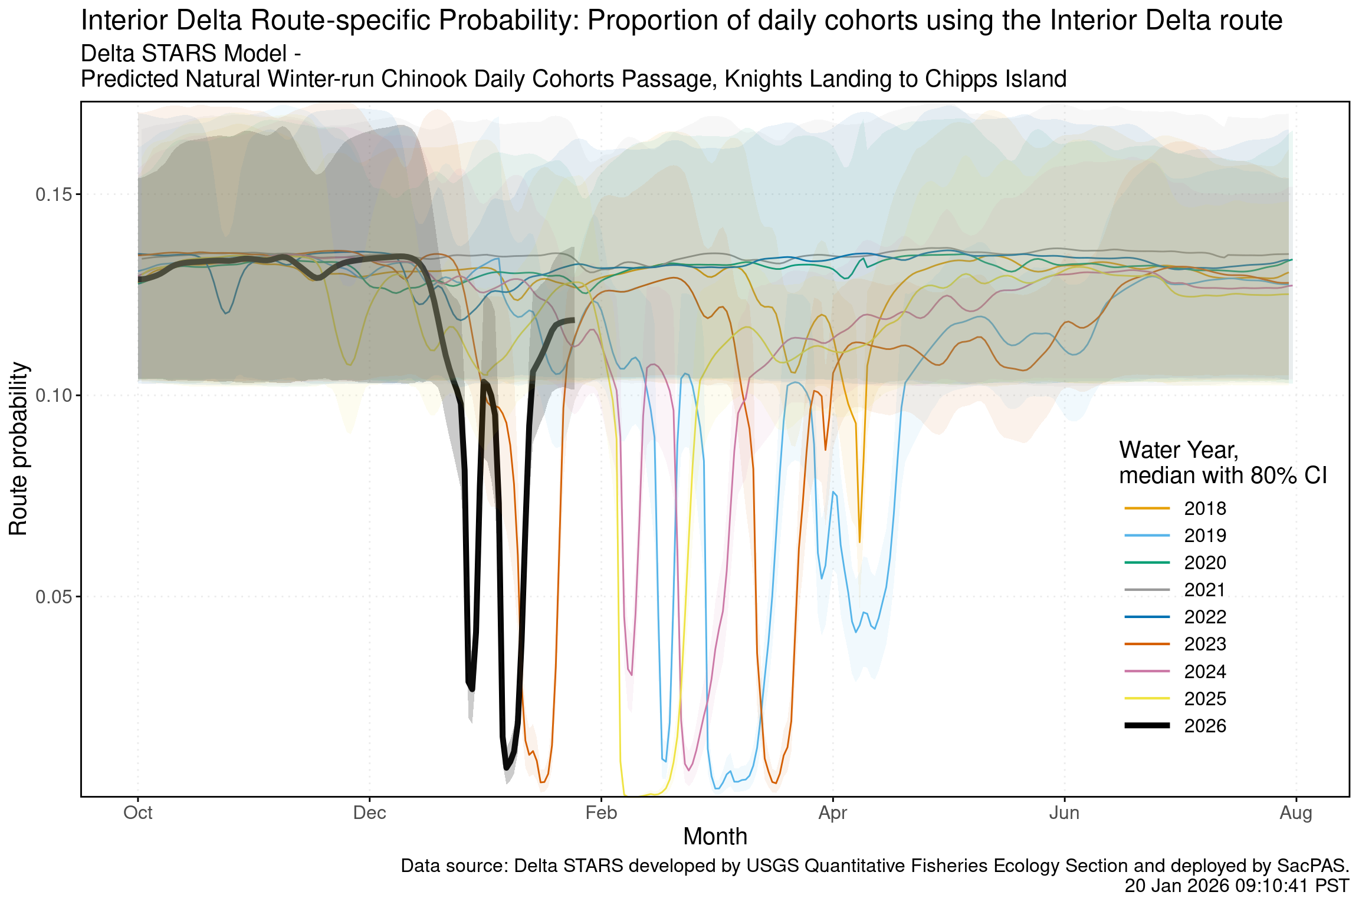
Figure 6: Estimated probability of winter-run routing into the interior delta. Black line indicates the current water-year, and other colored lines correspond to past water years.

2.2 Hatchery Winter-run Chinook

2.2.1 Hatchery Releases
To date, no winter-run Livingstone hatchery releases have occurred in WY 2026

2.2.2 Juvenile Production Estimate
The Juvenile Production Estimate for hatchery winter-run is 130,096 for Livingston Stone releases.

2.2.3 Annual Loss
To date, no loss has occurred as no hatchery winter-run have been released.

2.3 Natural-origin Central Valley Steelhead

2.3.1 Current Status
Delta Entry Timing - Historically, as of Jan 19, 26% of CCV steelhead have entered the delta based on Knights Landing RST catch, 2% have exited the delta based on Chipps Island Trawl Catch, and 7% have been salvaged.
Table 3: Average Percent of annual emigrating population for unclipped CCV steelhead captured at the following locations and salvaged at SWP and CVP Delta facilities for the past 10 years.
Species | Red Bluff Diversion Dam | Tisdale RST | Knights Landing RST | Sac Trawl (Sherwood) | Chipps Island Trawl | Salvage
Steelhead, Unclipped | 1% | 20% | 26% | 2% | 2% | 7%

Delta Monitoring - Total catch of LAD winter run at RSTs at Delta Entry (Tisdale, Knights Landing, Lower Sacramento River) between Jan 06 and Jan 12 is 0 individuals. Total catch at Sacramento Trawl and Beach Seines in the delta between Jan 07 and Jan 16 is 0 individuals. Total catch at Delta Exit at Chipps Island between Jan 06 and Jan 08 is 0 individuals.

2.3.2 Annual Loss
As of January 19, cumulative loss of unclipped steelhead is 43.91 or 0.83% of the incidental take limit in the NMFS Biological Opinion. Cumulative loss in the past 7 days has been 25.98.
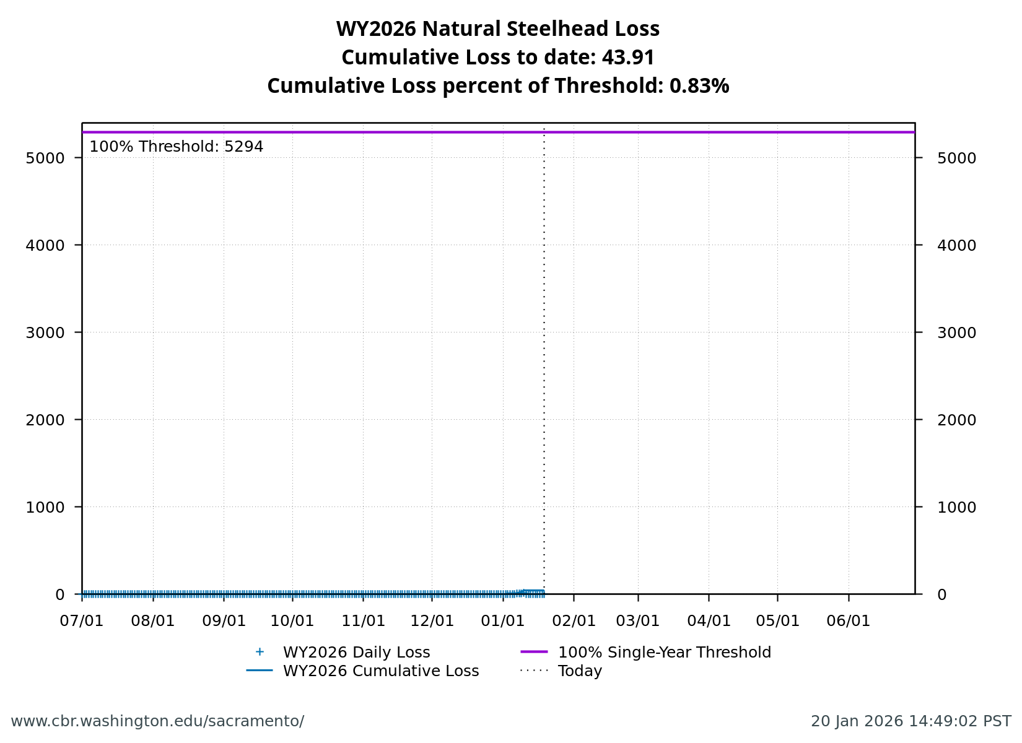
Figure 7: Cumulative loss of natural-origin steelhead for WY 2026.

2.4 Hatchery-origin Central Valley Steelhead

2.4.1 Surrogate Releases
There have been a total of 5 releases totaling 1,373,848 steelhead in Water Year 2026. JPE for the hatchery releases as of today is 591,419 based on estimated survivals using forecasted water year types (see details in table below). The annual loss threshold, equal to 1% of the JPE, is currently 5914, but is subject to change with additional steelhead releases.
Table 4: Summary of steelhead hatchery releases in Water Year 2026
Hatchery | Date of Release | Number Released | Estimated Survival | Juvenile Production Estimate
NIM | 2025-11-10 | 233,109 | 72% | 167,838
Coleman | 2025-12-15 | 555,720 | 38% | 211,174
Coleman | 2025-12-17 | 90,019 | 38% | 34,207
FRH | 2026-01-06 | 371,250 | 36% | 133,650
FRH | 2026-01-09 | 123,750 | 36% | 44,550

Total loss of hatchery-origin steelhead is 148.05 or 2.5% of the threshold. *Note that hatchery origin of salvaged fish can not be determined at this time and salvage is based on the assumption of similar routing and survival probabilities of individual hatchery releases.
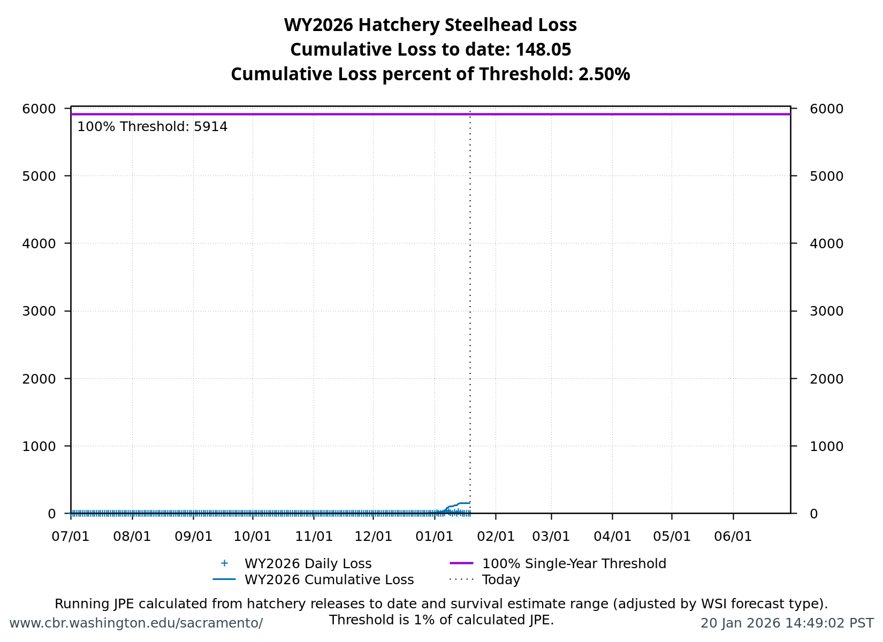
Figure 8: Cumulative loss of hatchery steelhead for WY 2026.

2.5 Spring-run

2.5.1 Current Status
Delta Entry Timing- Historically, as of Jan 19, 27% of LAD spring run have entered the delta based on Knights Landing RST catch, 0% have exited the delta based on Chipps Island Trawl Catch, and 0% have been salvaged.
Table 5: Average Percent of annual emigrating population for LAD Spring-run Chinook Salmon captured at the following locations and salvaged at SWP and CVP Delta facilities for the past 10 years.
Species | Red Bluff Diversion Dam | Tisdale RST | Knights Landing RST | Sac Trawl (Sherwood) | Chipps Island Trawl | Salvage
Chinook, LAD Spring-run, Unclipped | 13% | 16% | 27% | 2% | 0% | 0%

Red Bluff Diversion Dam Passage Estimate - As of Dec 31 estimated passage to date of LAD spring run at Red Bluff Diversion is approximately 0.02 million fish. * Note that outmigration timing overlaps with winter run and fall run outmigration, and true spring run abundance likely differs from these estimates.
Delta Monitoring- Total catch of LAD winter run at RSTs at Delta Entry (Tisdale, Knights Landing, Lower Sacramento River) between Jan 06 and Jan 12 is 103 individuals. Total catch at Sacramento Trawl and Beach Seines in the delta between Jan 07 and Jan 16 is 0 individuals. Total catch at Delta Exit at Chipps Island between Jan 06 and Jan 08 is 0 individuals.

2.5.2 Spring-run Surrogate Releases
A total of 805,323 spring-run surrogate fish have been released in Water Year 2026, with an estimated Juvenile Production Estimate (JPE) of 219,852 fish entering the Delta. This includes 805,323 Coleman Late-Fall Run Chinook (JPE: 219,852) released from Coleman National Fish Hatchery across 12 coded-wire tag groups. See details in table below.
Table 6: Spring-run Chinook Salmon Surrogate Releases (all Coleman Late-Fall releases, both production and experimental).
Hatchery | Release Date | Type | # of CWT Fish Released | JPE | Confirmed Loss | CWT Codes
Coleman NFH | 2025-11-13 | Production | 143,346 | 39,134 | 8.7 | 056808, 056809
Coleman NFH | 2025-11-17 | Experimental | 75,119 | 20,507 | 0.0 | 056810
Coleman NFH | 2025-12-17 | Production | 468,876 | 128,002 | 729.4 | 053700, 056806, 056811, 056812, 056814, 056815, 056817
Coleman NFH | 2025-12-22 | Experimental | 60,873 | 16,618 | 254.4 | 056813
Coleman NFH | 2026-01-08 | Experimental | 57,109 | 15,591 | 0.0 | 056816

2.5.3 Annual Loss
The annual loss threshold is 1% of the JPE entering the Delta, which equals 2,199 fish. As of January 19, cumulative loss is 992.49 fish or 45.14% of the annual loss threshold.

2.6 Loss Prediction and Trajectories
The following figures display the cumulative loss trajectories relative to historical years (“Spaghetti Plots”) and the current loss predictor model outputs for Winter-run Chinook Salmon and Steelhead.
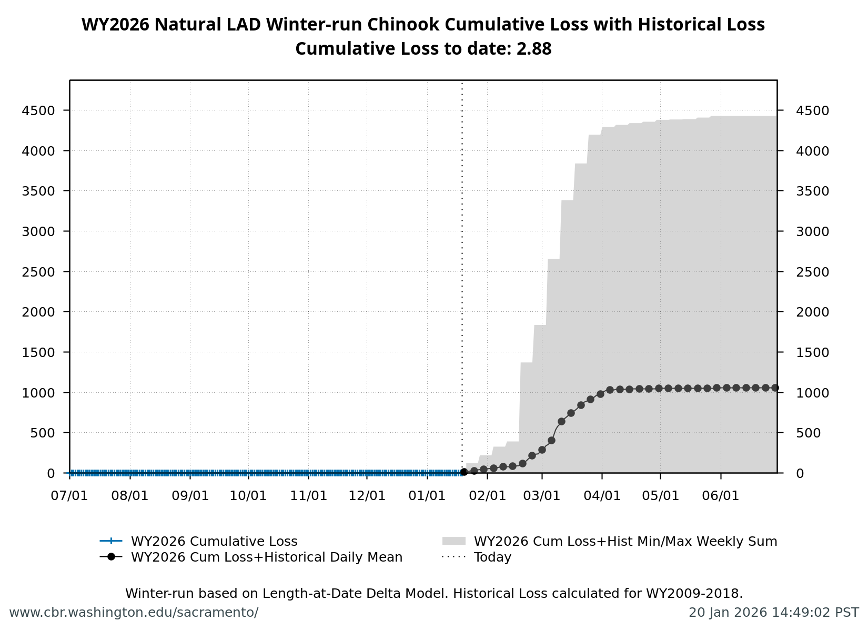
Figure 9: Natural LAD Winter-Run Chinook Salmon Loss Cumulative to Date with historical years and Single Year Loss Thresholds.

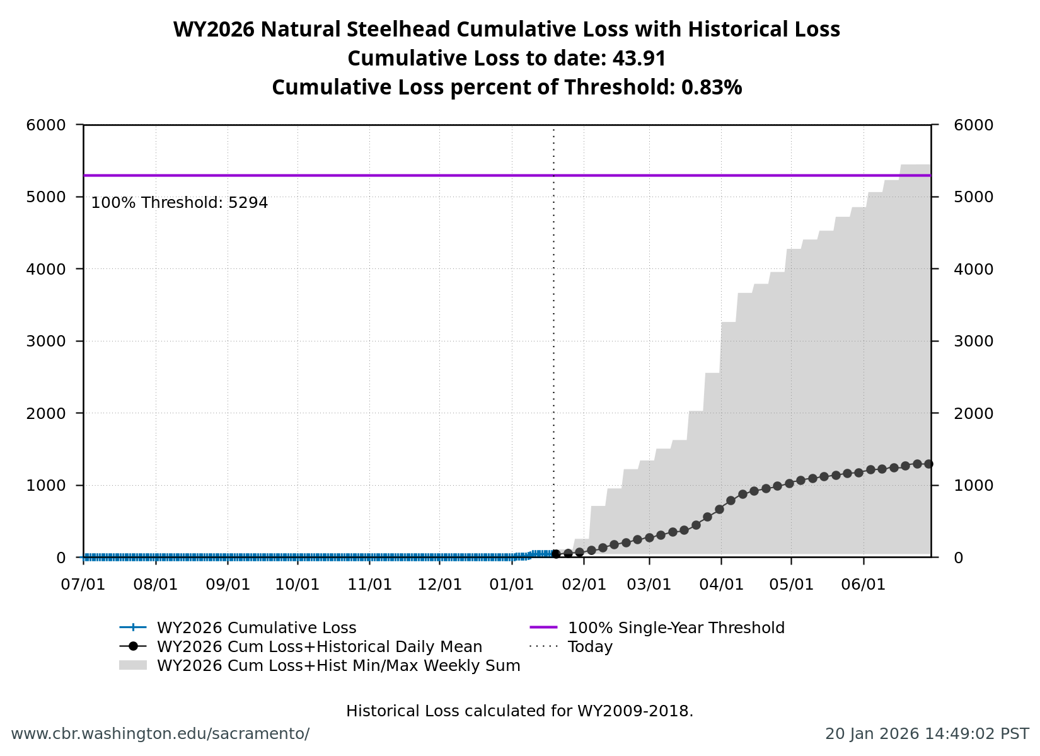
Figure 10: Natural Central Valley Steelhead Loss Cumulative to Date with historical years and Single Year Loss Thresholds.

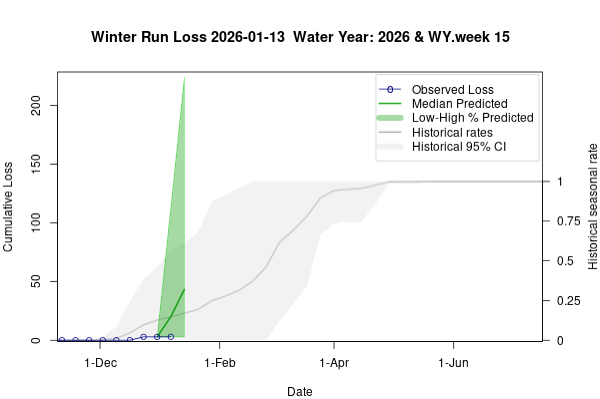
Figure 11: Estimates of Winter-run Chinook Loss generated by Loss and Salvage Predictor tool.

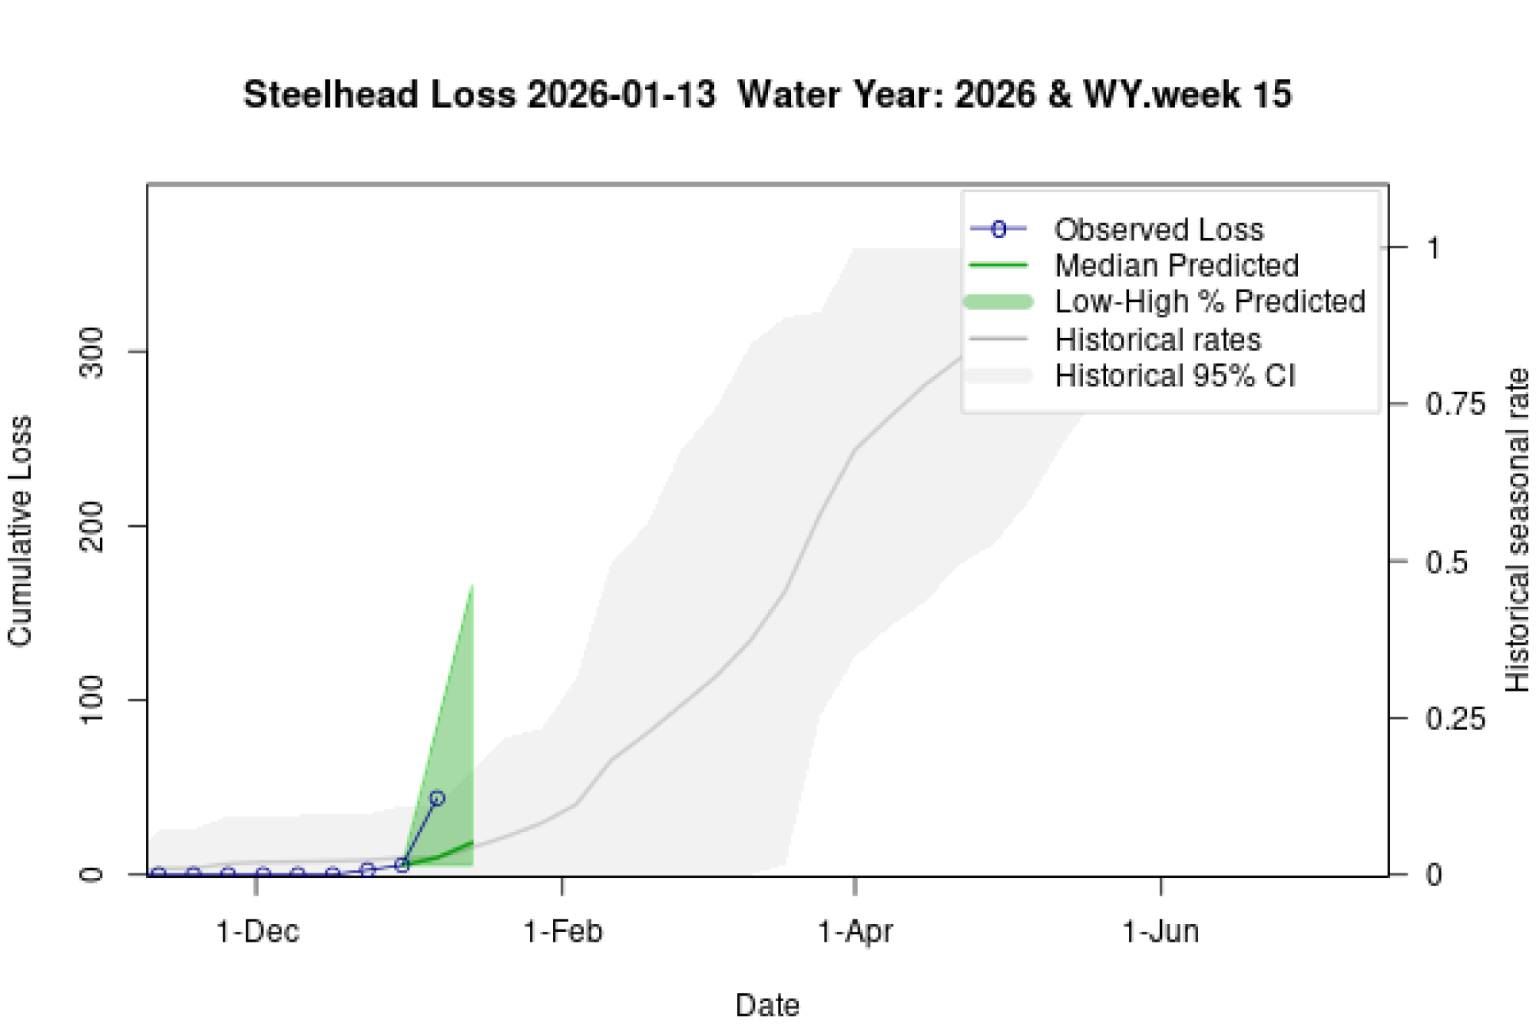
Figure 12: Estimates of Steelhead Loss generated by Loss and Salvage Predictor tool.

2.7 Evaluation
- What is the probability of exceeding natural or hatchery winter-run Chinook Salmon loss thresholds in the upcoming week?
- LOW RISK: Cumulative loss is currently 0% of the threshold. Current trajectory suggests the threshold is unlikely to be exceeded in the upcoming week.
- What is the probability of spring-run hatchery Chinook Salmon loss thresholds in the upcoming week?
- LOW RISK: Cumulative loss is currently 45.1% of the threshold. Current trajectory suggests the threshold is unlikely to be exceeded in the upcoming week.
- What is the probability of hatchery Steelhead loss thresholds in the upcoming week?
- LOW RISK: Cumulative loss is currently 2.5% of the threshold. Current trajectory suggests the threshold is unlikely to be exceeded in the upcoming week.

3 Weekly Assessment for Delta Operations on ESA and CESA-listed Osmerids

3.1 Operational and Regulatory Conditions
- See current Weekly Fish and Water Operations Outlook document.
- Additional information also available on the SacPAS SMT page.

3.2 Delta smelt

3.2.1 Biological
- Delta smelt life stages: Adult, Juvenile
- Abundance estimate: 8963 (95% CL: 1,984 to 26,236) as of the week of January 5–9, 2026
- Releases: A total of 163,349 cultured Delta smelt have been released for WY 2026. The most recent release of 24,606 fish occurred in Sacramento River at Rio Vista on Dec 16, 2025.
- Delta smelt count: 33 adult Delta smelt and 24 juvenile Delta smelt have been detected this water year. See Table 7 for recent detections, Figure 13 for spatial distribution, and Figure 14 for temporal distribution.
- Delta smelt salvage: 0 Delta smelt have been salvaged, and the cumulative seasonal salvage is 0.
Notes
- Since there are few recent detections of Delta smelt, estimation of distribution within the Delta is limited.
- As mentioned in EDSM reporting, fork length ranges reported for Delta smelt and longfin smelt life stages are defined by permit reporting purposes and are not intended to delineate cohorts or distinguish from hatchery or wild origin. See Table 7 caption for fork-length ranges for age groups of Delta smelt.
- See SacPAS SMT Page for additional details on releases and detection in surveys and salvage.
- Historical salvage trends can be found at: SacPAS Salvage Timing
Table 7: Delta smelt detections in the last 2 weeks. Fork Length > 58mm = Adult, Fork Length 20-58mm = Juvenile, Fork Length < 20mm = Larva.
Survey | Date | Region | Stratum | Life Stage | Catch
EDSM | 2026-01-07 | West | Suisun Marsh | Adult | 1
EDSM | 2026-01-07 | West | Suisun Marsh | Juvenile | 1
EDSM | 2026-01-08 | West | Suisun Marsh | Adult | 3
EDSM | 2026-01-08 | West | Suisun Marsh | Juvenile | 1

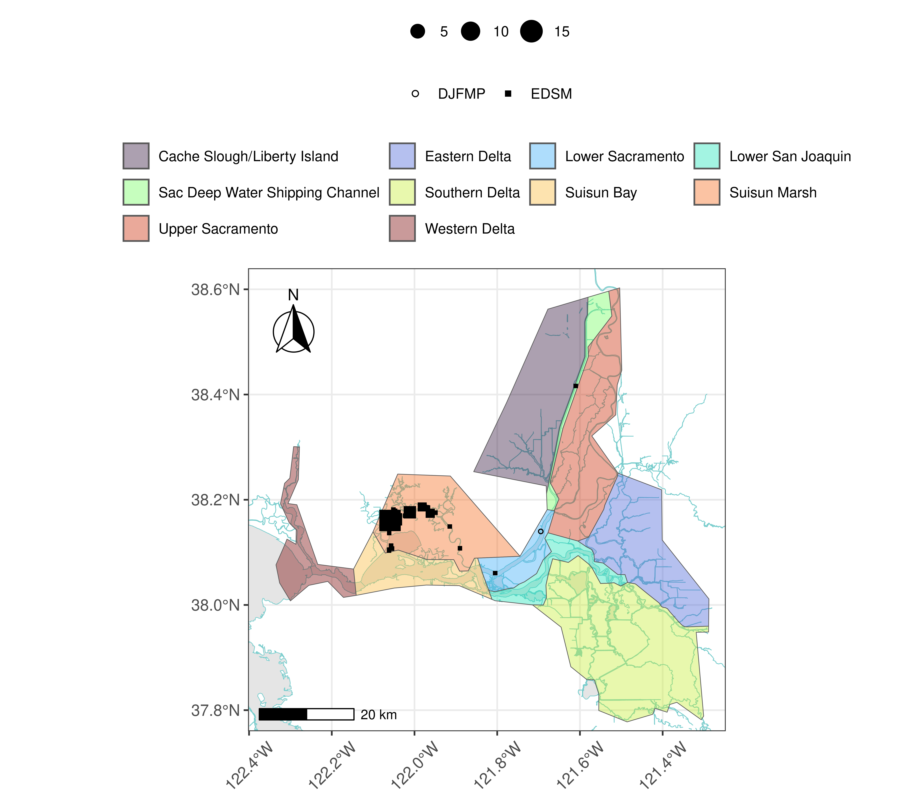
Figure 13: Delta smelt distribution for WY 2026
Table 8: Delta smelt water year totals by life stage
Survey | Region | Life Stage | Total
DJFMP | North | Juvenile | 1
EDSM | North | Adult | 1
EDSM | West | Adult | 32
EDSM | West | Juvenile | 23

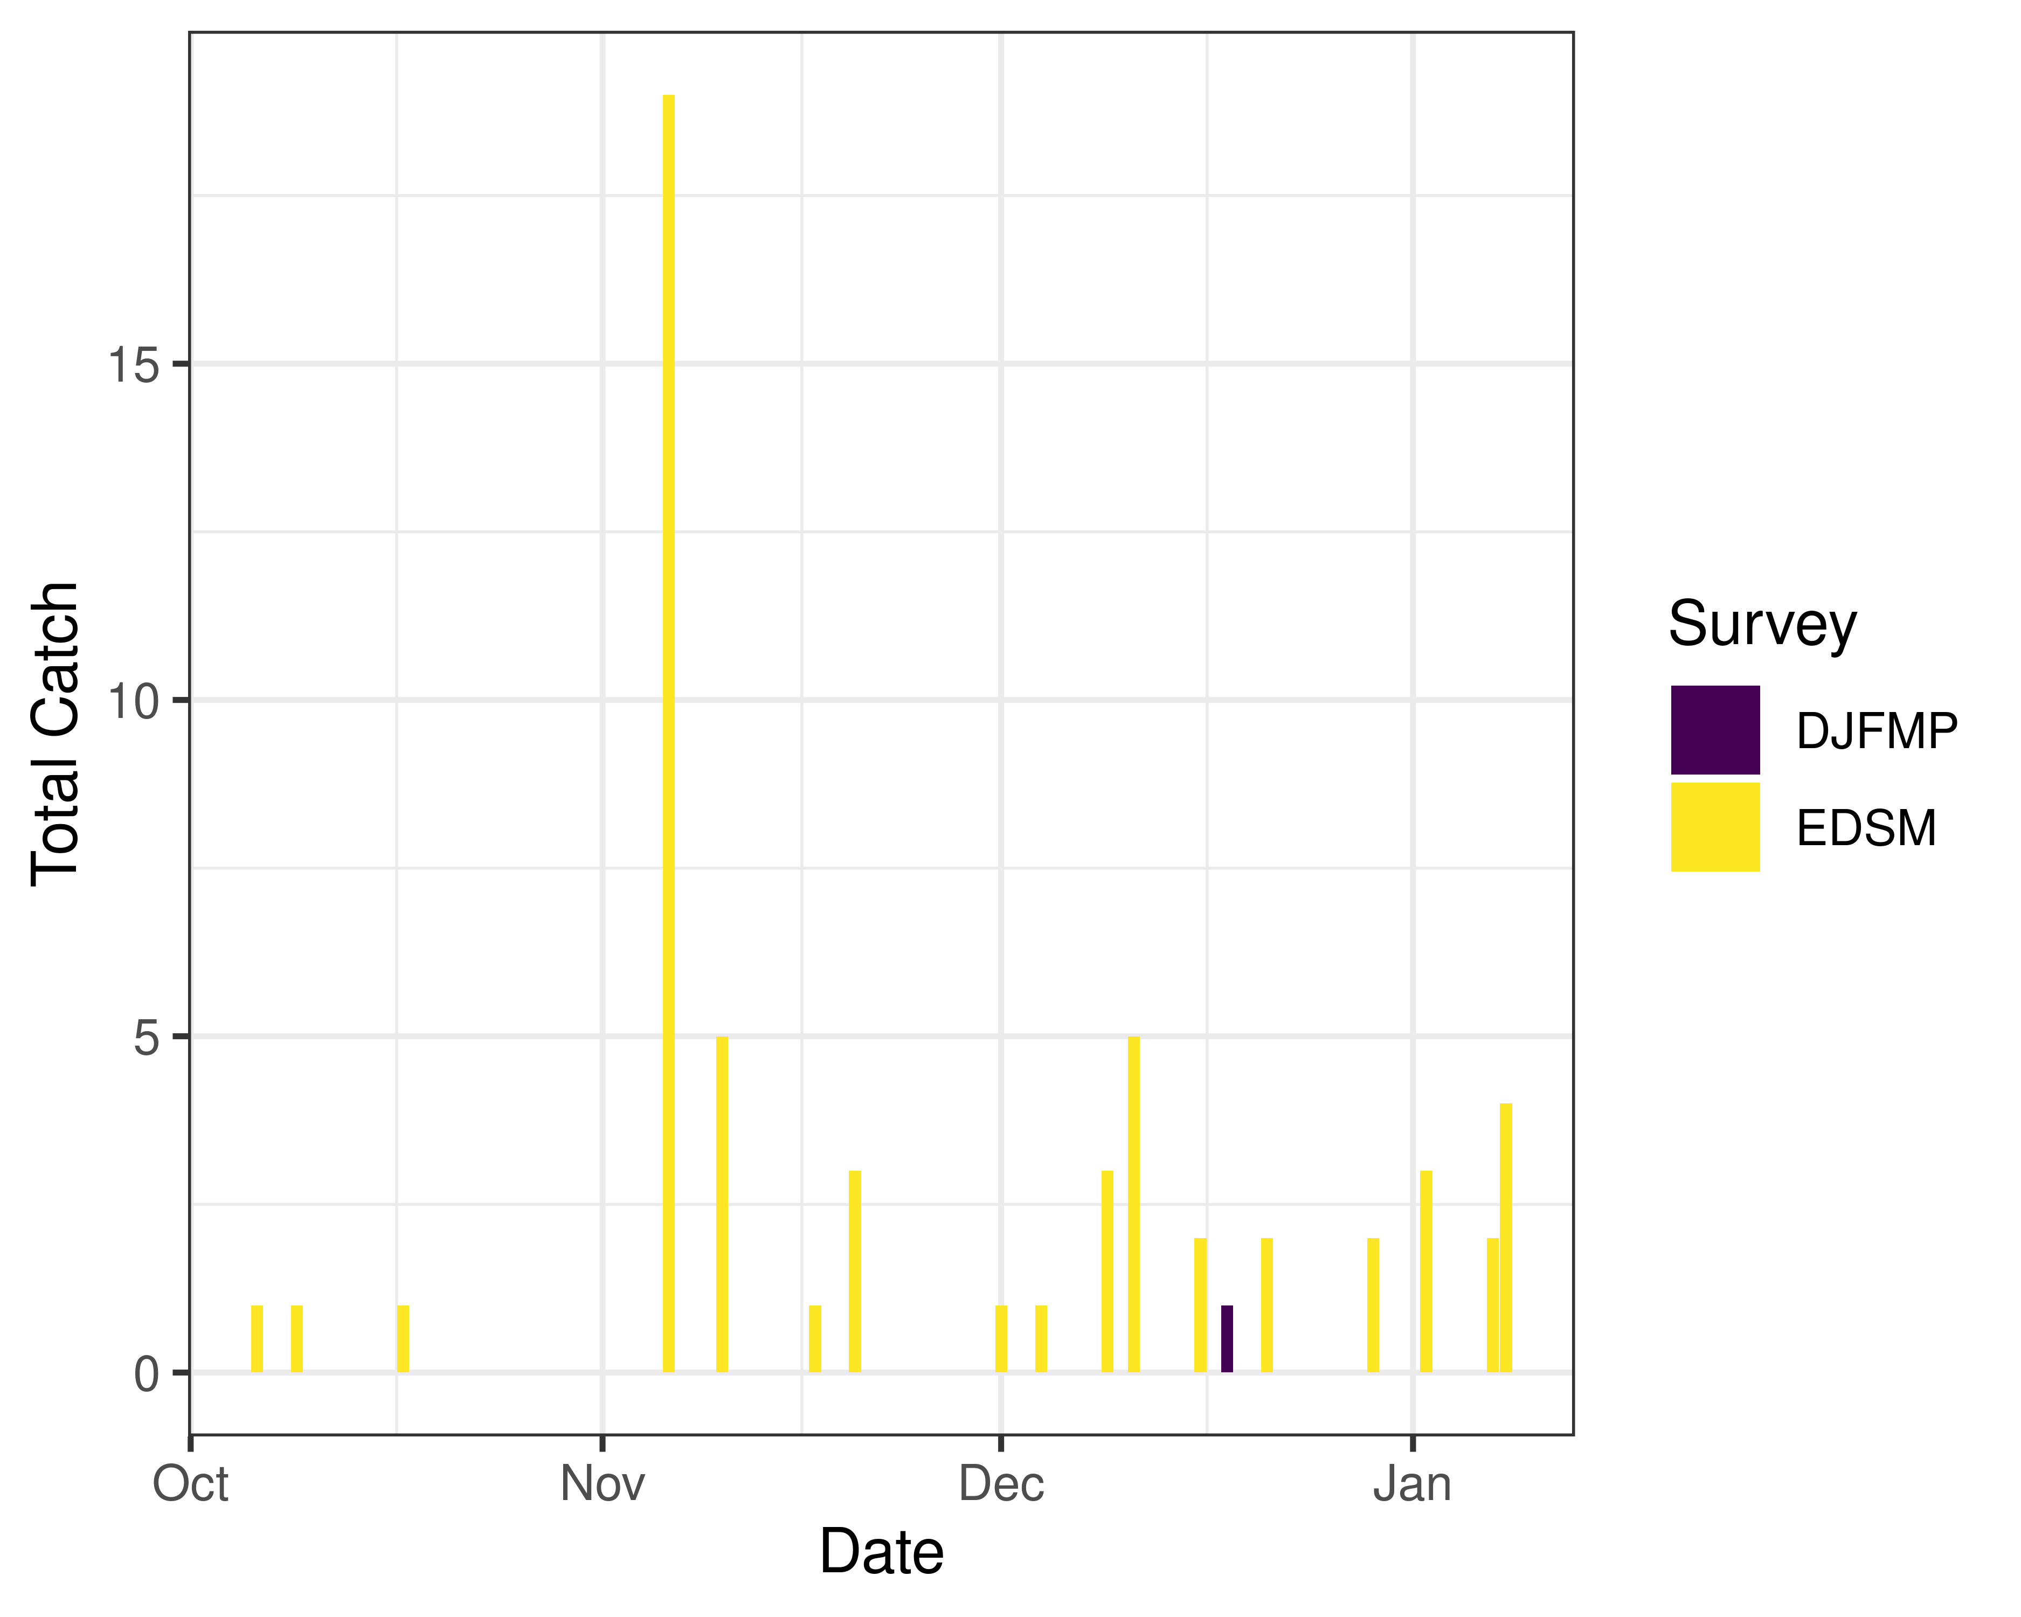
Figure 14: Time series of Delta smelt catch, WY 2026

3.2.2 Environmental

3.2.2.1 First Flush
- Not relevant

3.2.3 Real-time Assessment Thresholds

3.2.3.1 Adult Delta smelt
Threshold: If daily average JPF < 0 AND turbidity $≥$ 12 FNU at OBI, HOL and OSJ
- JPF: 8,082 cfs as of Jan 15, 2026
- OBI Turbidity: 7.07, 7.02, 6.85 FNU as of Jan 19, 2026
- HOL Turbidity: 6.85, 6.65, 6.44 FNU as of Jan 19, 2026
- OSJ Turbidity: 13.86, 13.12, 12.06 FNU as of Jan 19, 2026
Offramp Adult Protections when RVB or SJJ > 12$​^{∘}$C
- RVB temperature (3-day average): 10.37$​^{∘}$C as of Jan 19, 2026
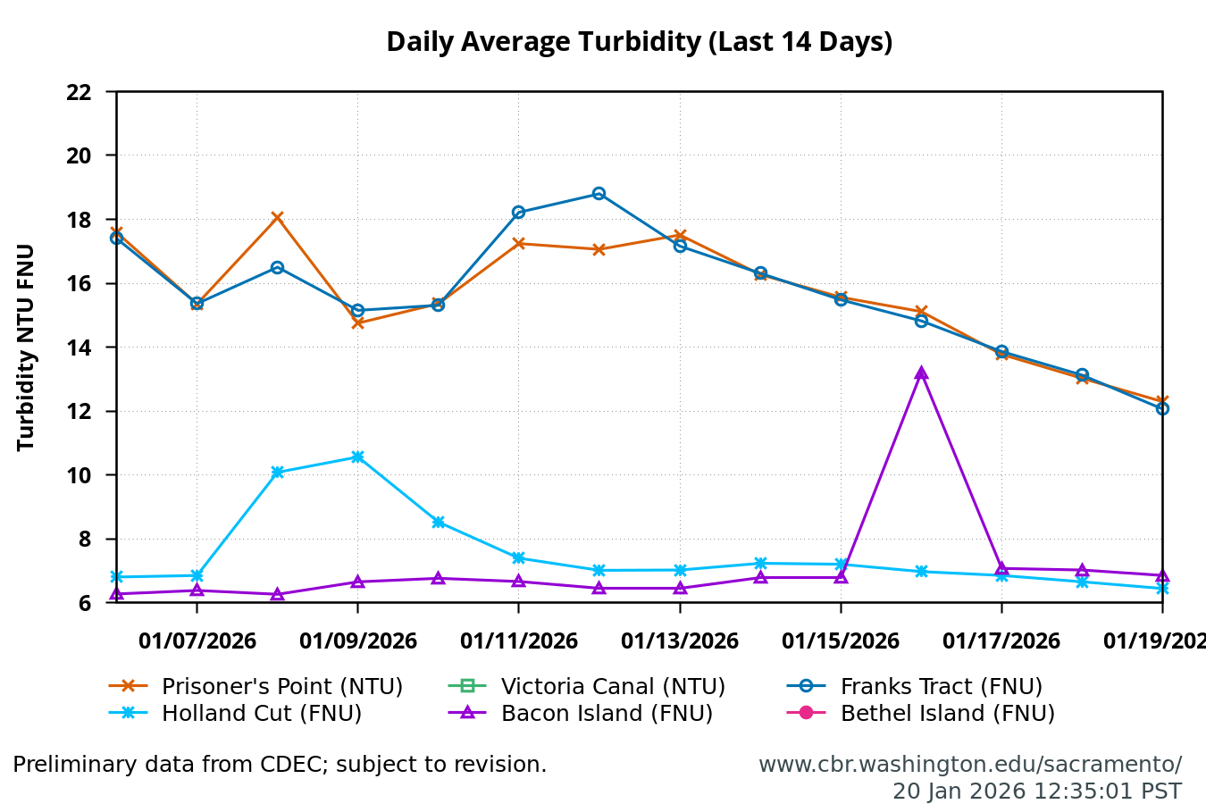
- See Bay-Delta Live for recent Delta-wide turbidity conditions.

3.2.3.2 Larval/juvenile Delta smelt
Threshold: After the onset of spawning, if JPF < 0 cfs AND turbidity is $≥$ 12 FNU in the south Delta AND PTM modeling indicates the action would avoid $≥$ 5% entrainment of Delta smelt population after 30 days
- 12-station South Delta Turbidity: The most recent average turbidity was 12.5 FNU as of Jan 13, 2025

3.2.4 Evaluation
Delta smelt:
- After the start of entrainment management, is JPF < 0 and is daily average turbidity $≥$ 12 FNU in the OMR corridor (stations OBI, HOL, and OSJ)?
- No, these conditions will not be met this week.
- Has the average water temperature at Jersey Point or Rio Vista not exceeded 53.6$​^{∘}$F (12$​^{∘}$C) for 3 consecutive days and/or has this action already been taken during WY 2026?
- Temperature at Rio Vista or Jersey Point has not exceeded the threshold. The Delta smelt adult entrainment management action has not yet been taken in WY 2026.
- What is the evidence for the onset of Delta smelt spawning?
- Upstream migration for Delta smelt occurs between September and December and in response to “first flush” conditions (Sommer et al. 2011, Grimaldo et al. 2009). Migration typically ranges one to four weeks after flow and turbidity increases, based on salvage data (Sommer et al. 2011). Historically, detections of ripe Delta smelt began in January and peaked in February and March and the majority of Delta Smelt spawning occurs within a temperature range of 9-18˚C (Damon et al. 2016). Based on historical monitoring data from the past few years, first detection of larvae in the Central and South Delta has typically occurred by mid to late March. Because first flush conditions were met on December 23, 2025, spawning may begin occurring during the current assessment week, consistent with the typical one- to four-week response window following increased flow and turbidity.
- After the onset of spawning, have the following conditions occurred: $≥$ 5% entrainment of the Delta smelt population at facilities after 30 days?
- Although spawning may begin during the current assessment period, JPF is above 0 cfs; therefore, the conditions required to evaluate larval and juvenile Delta smelt entrainment management are not met.

3.3 Longfin smelt

3.3.1 Biological
- Longfin smelt life stages: Juvenile, Adult, Larva
- Longfin smelt count: 297 adult, 461 juvenile, and 122 larval longfin smelt have been detected this water year. See Table 9 for recent detections, Figure 15 for spatial distribution, and Figure 16 for temporal distribution.
- Longfin smelt salvage: 0 longfin smelt have been salvaged, and the cumulative seasonal salvage is 0.
Table 9: Longfin smelt detections in the last 2 weeks. Fork Length > 84mm = Adult, Fork Length 20-84mm = Juvenile, Fork Length < 20mm = Larva.
Survey | Date | Region | Stratum | Life Stage | Catch
DJFMP | 2026-01-08 | N/A | Chipps Island | Adult | 3
EDSM | 2026-01-07 | West | Suisun Marsh | Juvenile | 1
EDSM | 2026-01-12 | North | Lower Sacramento | Juvenile | 1
EDSM | 2026-01-12 | West | Lower Sacramento | Adult | 19
EDSM | 2026-01-12 | West | Lower Sacramento | Juvenile | 5
EDSM | 2026-01-13 | Far West | Western Delta | Juvenile | 2
EDSM | 2026-01-20 | Far West | Suisun Bay | Juvenile | 13
EDSM | 2026-01-20 | West | Lower Sacramento | Adult | 1
sls | 2026-01-12 | South | Lower San Joaquin | Larva | 2

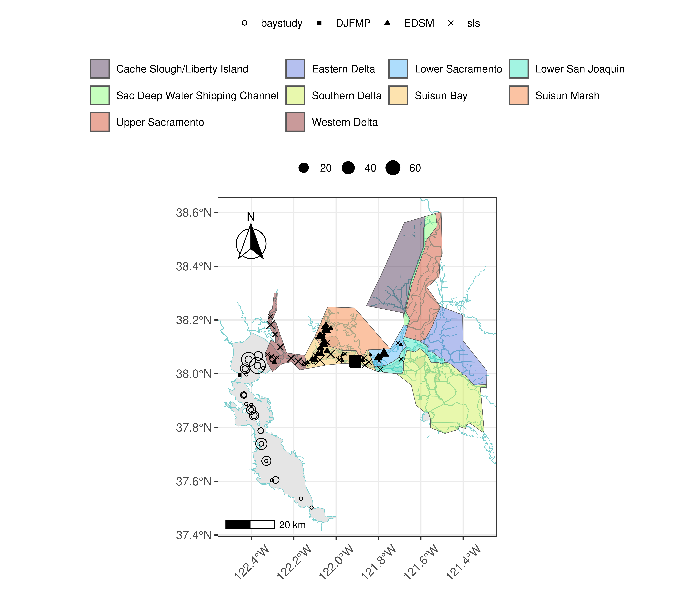
Figure 15: Longfin Smelt Distribution for WY 2026
Table 10: Longfin smelt water year totals by life stage
Survey | Region | Life Stage | Total
DJFMP | Bay | Juvenile | 1
DJFMP | N/A | Adult | 240
DJFMP | N/A | Juvenile | 14
EDSM | Far West | Adult | 7
EDSM | Far West | Juvenile | 28
EDSM | North | Juvenile | 1
EDSM | West | Adult | 42
EDSM | West | Juvenile | 80
baystudy | Bay | Adult | 6
baystudy | Bay | Juvenile | 320
baystudy | Far West | Adult | 2
baystudy | Far West | Juvenile | 11
baystudy | West | Juvenile | 6
sls | Far West | Larva | 82
sls | North | Larva | 2
sls | South | Larva | 2
sls | West | Larva | 36

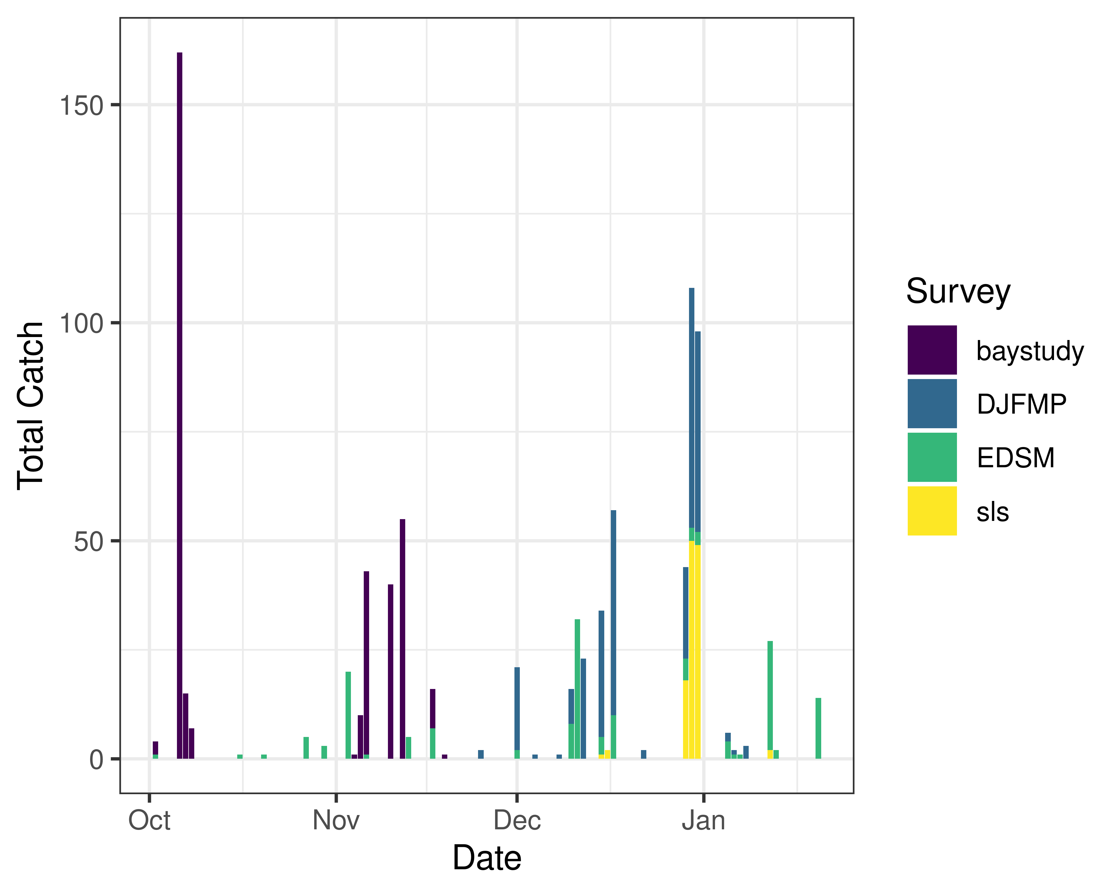
Figure 16: Time series of longfin smelt catch, WY 2026

3.3.2 Real-time Assessment Thresholds

3.3.2.1 Start of Entrainment Management (Adult Longfin Smelt)
- Not relevant

3.3.2.2 Adult longfin smelt
- Threshold: JPF < 0 cfs, annual loss is on a trajectory to exceed 5% of the adult population abundance, and reduced exports will reduce entrainment in the south Delta
  - Daily average JPF: 8,082 cfs as of Jan 15, 2026
  - Adult abundance (Age 1+ LFS index): 2479.2 fish
    - 5% of abundance + 1: 125.0
  - Water year total adult longfin smelt salvage = 0

3.3.2.3 Larval/juvenile longfin smelt
- Threshold: JPF < 0 cfs AND population model demonstrates need to reduce entrainment to avoid population decline
  - Daily average JPF: 8,082 cfs as of Jan 15, 2026

3.3.3 Evaluation
Longfin smelt:
- If JPF < 0, what is the trajectory of annual loss of adult longfin smelt and is it likely to exceed 5% of the adult population estimate? Is South Delta entrainment expected to decrease due to a reduction in export pumping?
- JPF is not < 0 cfs and no adult longfin smelt have been detected in salvage.
- For larval and juvenile longfin smelt, if JPF < 0 cfs, do particle tracking models show a moderate to high difference in particle fates across different OMRI scenarios? Does Zone of Influence modeling show moderate to high changes in hydrodynamic footprint across different OMRI scenarios? Are these effects anticipated to cause a population decline?
- JPF is not < 0 cfs. ZOI modeling shows moderate change in the hydrodynamic footprint between OMRI scenarios, but no change between current and forecasted conditions.
- Is there additional information or other analyses that should be considered in this evaluation?
- Additional information may be discussed if needed at the DAT call.

3.4 End of smelt Entrainment Management
- Not relevant

3.5 References
Damon, L. J., S. B. Slater, R. D. Baxter, and R. W. Fujimura. 2016. Fecundity and reproductive potential of wild female Delta smelt in the upper San Francisco Estuary, California. California Fish and Game 102(4):188–210.
Grimaldo, L. F., T. Sommer, N. Van Ark, G. Jones, E. Holland, P. B. Moyle, B. Herbold & P. Smith (2009) Factors Affecting Fish Entrainment into Massive Water Diversions in a Tidal Freshwater Estuary: Can Fish Losses be Managed? North American Journal of Fisheries Management, 29:5, 1253-1270, DOI: 10.1577/M08-062.1
Sommer, T., F. Mejia, M. Nobriga, and L. Grimaldo. 2011. The Spawning Migration of Delta Smelt in the Upper San Francisco Estuary. San Francisco Estuary and Watershed Science 9(2).

